1. Provide the name of the game and a brief description of the goal of the game.
   1. Bioshock – A first person shooter (FPS) set in the 1960’s where the player character Jack’s airplane crashes in the middle of the ocean next to a lighthouse. Jack goes inside the lighthouse and discovers a bathysphere which takes him to an underwater city. Jack must fight his way out of the city by utilizing a variety of weapons and abilities gained throughout the game.
2. What are some specific game play features that make this game your favorite? List up to five features and provide a brief description as to WHY you think each feature helps make this game your favorite?
   1. Story – the story was unique at the time of release, and has a wonderful twist that I didn’t see coming until it was too late.
   2. Atmosphere – the game does an excellent job of make you feel isolated and claustrophobic by the art style, and sound design
   3. Ability choices – as the player progresses through the game they are able to modify the way they play the game by which powers/abilities they use and upgrade
   4. Character development – as the player progresses their relationship with some of the NPC’s changes based on their choices
   5. Collectables – the collectables in the game help enhance the story of what happened to the city before the player gets there, and expands on the story.
3. What are some limitations and/or areas of improvement that you might recommend to make the game even better? List up to three recommendations including a brief rationale for each.
   1. Abilities – some abilities almost feel like “must haves” to complete the game. It would also be nice to have more abilities or branching ability trees
   2. Endings – the game only has two endings based on how you behave, essentially a good and a bad ending, where it would be nice to have at least a grey (middle) ending
   3. Customized controls – I wish that you were able to customize your controls as the control scheme has some weird choices for what buttons perform which actions
4. 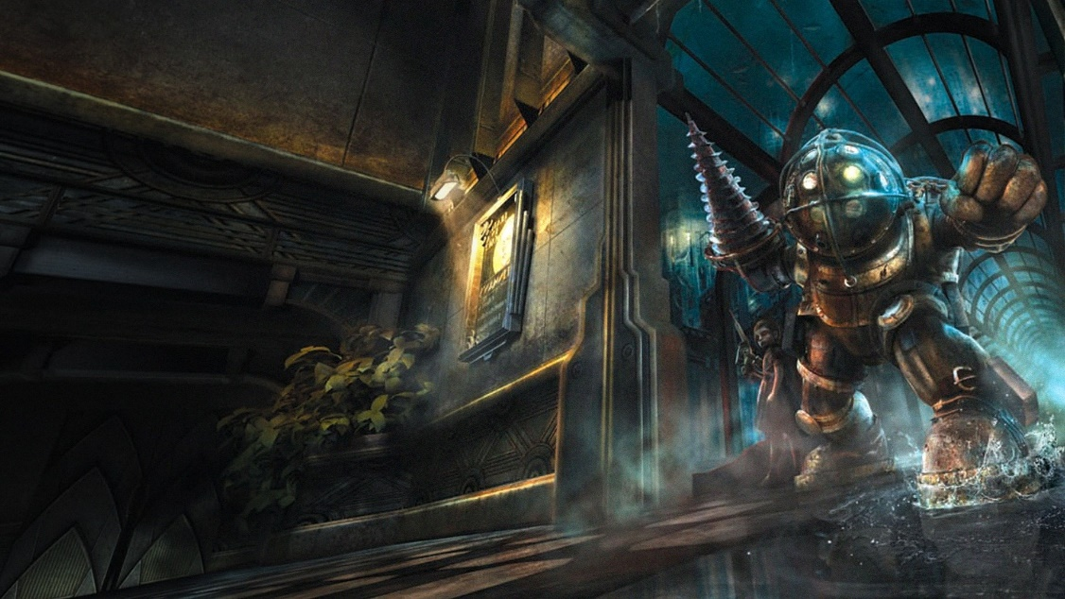Include a picture/screenshot of the game that helps identify it to others.